Project Proposal – CityPoint Room Hire
Summarised Set Task Brief – For my convenience’s purpose
CityPoint specialise in:
- Room hires for meetings, training, and private events
- Equipment hires such as projectors, speakers and seating
- Short-term and day-long bookings for community groups and businesses
The client would like me to develop a digital solution that will:
- Provide customers with info about:
  - Rooms for hire and their facilities
  - Booking policies and staff details for the company
- Allow customers to:
  - Book rooms for specific dates and times pending confirmation
  - View and manage their existing bookings
The client has suggested the following features:
- Account Registration to allow customers to manage their bookings and data
- Accessibility features to support a wide range of users
- A staff area to manage rooms and booking requests that they can confirm or deny
Research
Venue Hire Businesses
1: NEC Birmingham
The NEC is one of the largest venue sites in England, known for hosting massive events from business conferences to tournaments of all kinds and even concerts. For this reason, I found it to be a suitable comparison point given the information provided by the client in the Brief.
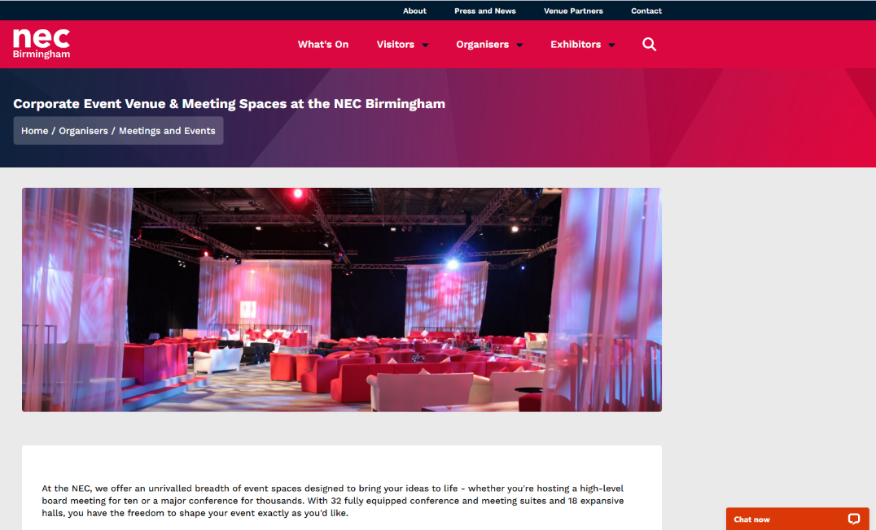
Immediately visible on the homepage of the website are a few things that stand out to me. Firstly, the presence of a chat menu (Bottom Right) To assist users with both AI and human chat assistants, and also the general layout of information.
The website for the NEC seems to take a double-headered approach to its layout, offering a smaller collapsible header with less commonly viewed tabs that does not follow the screen as it scrolls, and then also displaying a larger header with Information that would be more frequently accessed, such as “Visitors” or “What’s On,” Both of which would be relatively easy to repurpose for a site like the one our client would like.
The chatbot function also seen on this page would also offer as a merit to take away, as it is an efficient way to help a new user learn their way around the site or tackle any issues they may be having. Upon first loading the site, the “Chat Now” window expanded into a small chat menu with a pinging noise, immediately drawing user attention to it and making the box unmissable immediately.
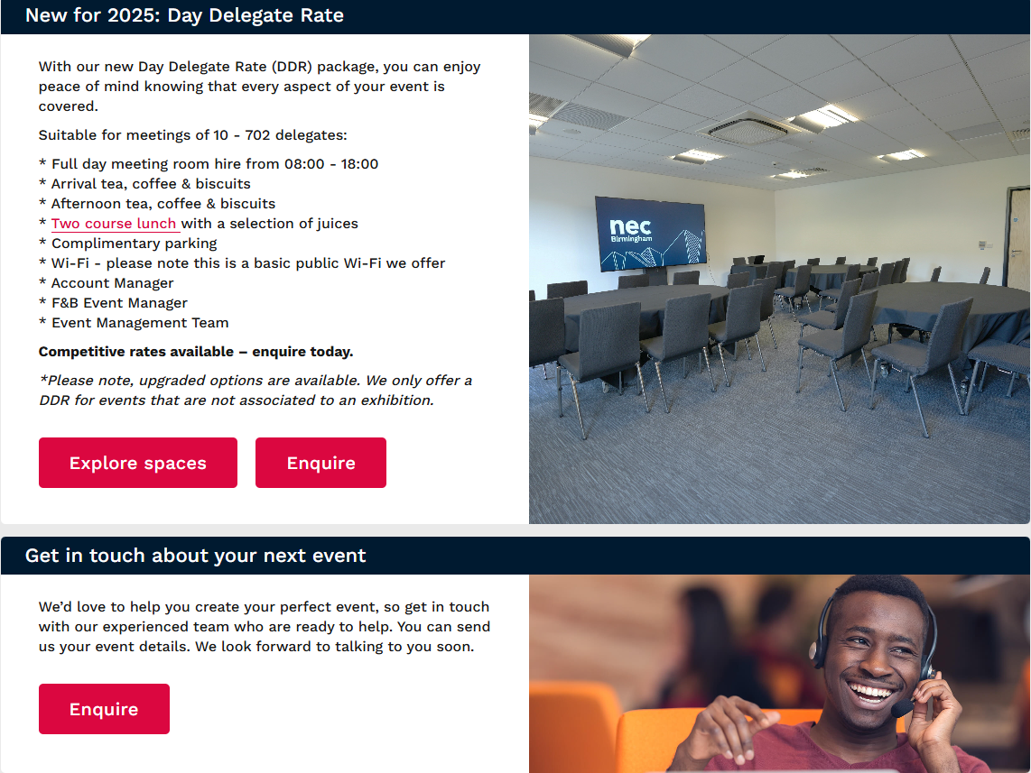
Scrolling further down on the main page, the site offers a selection of news posts and cards showing different accessible features on the site. This offers and easily scalable method of adding more content to the homepage.
Furthermore, this allows the developer to cycle the content on the homepage, keeping the website looking fresh and new at all times, without having to fully reinvent the site itself.
In conclusion, the NEC website offers a range of useful content that could be adapted into a client website to help meet the features specified in the brief, such as a chatbot and a scalable homepage.

2: HeadBox
HeadBox is a company more similar to that of CityPoint itself, offering more small venue hires in a wider area. After looking through what the site has to offer, I believe there is yet more things that the client’s digital solution could benefit from.
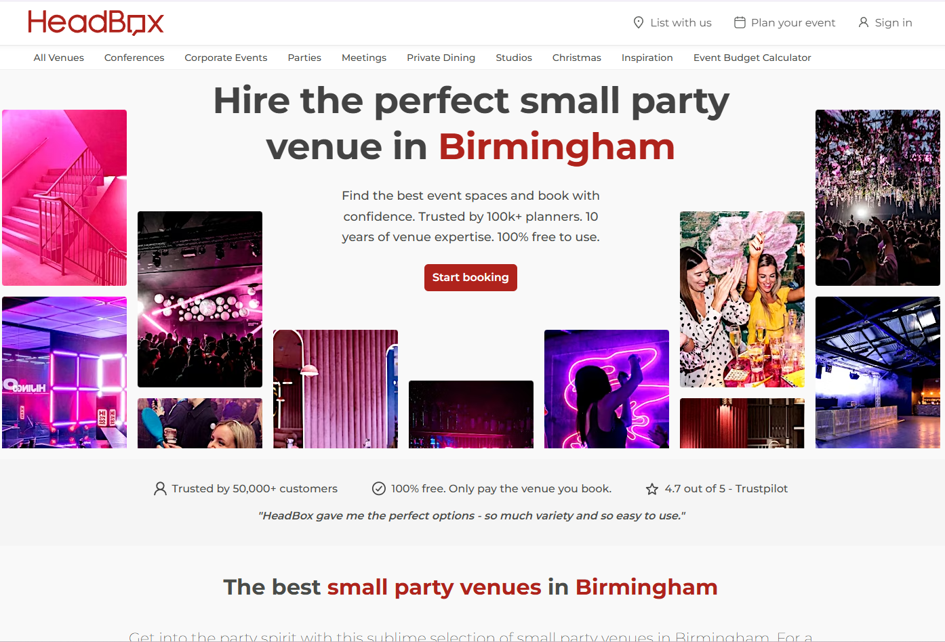
Immediately upon looking at the homepage I believe the visual design is one that draws the user in. It uses a void of colour in the centre to draw the user’s eyes to the one coloured thing in the negative space, that being the “Start Booking” button. It also offers several testimonials of user satisfaction, such as photos of happy customers utilising the venues, the number of customers using their services and their Trustpilot rating, along with a user quote to further emphasise the prior points.
I believe that while the above points offer a boost to visual appeal and UI/UX design, I think that there is still more to take away from this site. In the top right corner, there are 3 notable buttons, the furthest of which being “Sign In.” This is one of the features that was requested by the client and directly links to the digital solution we aim to make. Alongside that is another button to plan events, and a “List with us” button, taking the user to a separate part of the website made for venue owners.
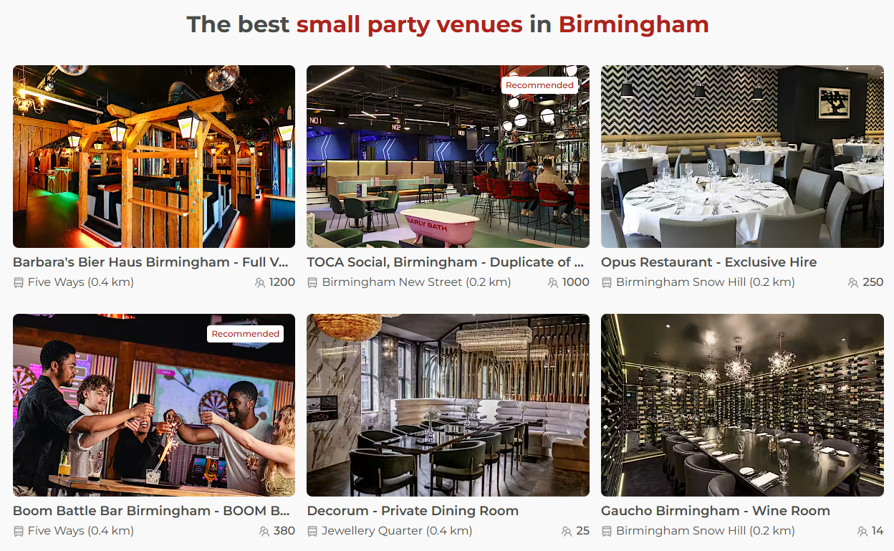
Scrolling further down, the user is met with a selection of rooms from HeadBox’s selection, offering some as “recommended,” and displaying a maximum capacity for each. I believe this method of offering a rotating selection of rooms on the homepage would tie into the client requesting that the digital solution offers customers information about rooms for hire and their facilities, allowing another key feature to be taken into account by this site.
In conclusion, I believe that from both a functional and a design standpoint, the HeadBox website offers a comprehensive insight into what a site in the venue hire industry should look like, offering several notable features that could be adapted into something for the client’s digital solution.

Business Context
- Provide Customers with info about rooms for hire and their facilities
This would help to solve the issue of venue sites having unclear or incorrect information surrounding their room availabilities, and often forcing users to wait in pending confirmation for days or weeks at a time. It is often underutilised or hard to navigate to in some websites, such as the NEC website, where I could not find its availability times

- Provide Customers with info about booking policies and staff details
This would allow customers to know exactly what they are paying for whilst also offering them legalese on staff and rooms. Offering more ways to clear up potential misconceptions with customers can be a clever thing to do, as its hard for some customers to know exactly what they are getting into by renting a venue. Mitigating potential misconceptions can help to eliminate the prospect of an unruly customer that may stop or slow business times, depending on the severity of their upset.

- Allow customers to book rooms for specific dates and times pending confirmation
Offering a system in which customers can book rooms for specified dates and times remotely offers a solution to multiple problems, one of which being eliminating the need for paper-based reservations that can clash or leave room for human error. It also helps to mitigate things like version control or customers being unable to see information on bookings, as all bookings could be handled digitally.

- Allow customers to view and manage their existing bookings
Allowing the customer to view and manage existing bookings would allow for users to check back up on bookings they had made previously, viewing things like status, details, and allowing them to edit certain details about the venue or to cancel the listing entirely. This would help to handle the issue of reservation mistakes being impossible to rectify and allows the user to change and adapt their plans as they need them, which can sometimes not be the case in some similar sites.

- Account Registration to allow customers to manage bookings and data
Allowing Account registration allows the customer to securely access their own personal booking information and to save their preferences on the site. This solves a number of large issues, such as problems regarding data security and privacy, and others like the user’s preferences and accessibility settings being saved to their account, so that when they log back in, they regain their accessibility settings.

- Accessibility features to support a wide range of users
Offering Accessibility features is a must for any industry-standard site, as it massively broadens the market of potential customers and traffic on the site. Offering settings like Text-To-Speech or Colourblind settings can be highly valuable settings to those who need it, and offering a comprehensive amount of accessibility settings can help the client’s site stand out amongst the competition. Accessibility settings also solve legal issues, such as needing certain features to pass as a functional website to be fit for company use.

- A staff area to manage rooms and booking requests that can be confirmed or denied
A staff portal to manage rooms and bookings would be a mandatory inclusion for the client, given how much information about rooms and bookings are now being stored on the site databases. Offering a separate user login with a higher access role would allow the staff to edit and update or deny booking requests remotely and with the click of a single button. This would help to mitigate clashing times and offers the added security of user roles to the website

Project Aim
- Based on the Business Context what is the overall projects aim and what are you looking to make.
- This should just be an overview
Project Aim: To create a user-friendly website prototype offering a functional bookings system for venues and rooms, in which users with standard access roles can access a menu to book from a local venue for a set amount of time over an allotted period. Separate users with higher “Staff” access roles can also access another part of the site that allows for bookings to be confirmed or denied. The website should contain standard accessibility settings, a Login/Register system to keep data private and secure, and Authorisation for only the booking creator and staff to view each specific booking for the same reason. The website must be efficient and easy to navigate and remain consistent throughout each page, to allow for each user to smoothly navigate through each page of the site without issue. The site will focus heavily on a range of accessibility settings, to allow for each and every user to navigate the site without issue.

Functional Requirements and User Acceptance Criteria
User 1: John, New customer, looking to book venues for work meetings, not very good with technology.
User 2: Jane, Experienced customer, looking to book a large venue to host a wedding, technologically sound but hard of sight.
User 3: Steve, Staff member, needs to use the site regularly for his work every day, somewhat technologically capable.
Functional Requirement | User Story | User Acceptance Criteria | Justification
The solution must allow users to book a room/venue | As John, I want to be able to book a room, so that I can hire out venues for my meetings. | User can access venue bookings button  User account details are cross-referenced with the booking  User can select a venue of their choosing  Users can select a start date & time for the venue hire  Users can select an end date & time for the venue hire  User can enter details of booking such as purpose of hire  Solution validates fields to check for input where mandatory  Solution validates format of inputted fields  Solution saves confirmed venue booking to the database  Staff and above should be able to view all bookings.  Solution must comply with Web Content Accessibility Guidelines  Solution must validate that dates chosen are valid and possible to be booked | Offering the ability to book a room would allow the customer to remotely book a venue out for their own use, whether that be a small venue for a work meeting or a larger one for a wedding or party.
The solution must allow users to view room/venue details | As John, I want to be able to view my booking details, so that I can check the information on my existing appointments | Users must be able to navigate to “My Bookings” button  Users must be able to see their bookings if they are logged in  Solution must redirect user to login page if they are not logged in  Solution must only show each specific user’s bookings to them  Staff and above can view all bookings for their venue  Super User must be able to access all bookings for any venue  Solution must comply with Web Content Accessibility Guidelines | Allowing the user to view the details of their existing bookings allows them to ensure that they have not made a mistake in any of their upcoming bookings and allows them to cross-reference it with their personal schedule.
The solution must allow staff to access bookings | As Steve, I want to access the bookings, so that I can see what bookings are scheduled for the upcoming weeks/months | Staff must be able to log in to their account  Staff users must be able to navigate to the “Venue Bookings” button  Staff users must then be able to see all bookings upcoming for their venue, along with details of bookings  Solution must comply with Web Content Accessibility Guidelines | Offering staff the ability to view all upcoming booking details allows for them to see what is due for their venue and allows them to prepare and see ahead of themselves.
The solution must provide customers with relevant information regarding their bookings | As Jane, I want to be provided with relevant information regarding my bookings, so that I can relay this information to other people who I am inviting. | Users must be able to navigate to their bookings  Solution must redirect user to login page if the user is not logged into an account  User must be able to see information relevant to the booking from the bookings screen (e.g.: Distance, Capacity, Address, etc.)  Solution must comply with Web Content Accessibility Guidelines | The solution providing customers with relevant booking information allows them to send this information out as venues are hired for larger groups of people and information such as the address, times, capacity, or +1 rules would offer a much more conclusive viewing experience for the customer
The user must be able to log into an account after registering | As John, I want to log into my account after registering, so that I can gain access to my bookings again even after I have left and re-entered the page. | User must be able to register an account using either email or google login.  User must then be able to click on “Log In” and access their account again.  Solution must check for repeated emails in account details.  Solution must comply with Web Content Accessibility Guidelines | Allowing the user to log back into their account after registering is imperative for the user to regain access to their booking information and account details. This is a highly important feature that must be included for the user experience, and for basic site intended functionality.
The user must be able to edit or remove their own bookings/information | As Jane, I want to be able to edit or remove my own bookings, so that I can change my plans should I need to later on. | User must be able to navigate to their booking menu  User must be able to navigate to the “Edit” button on each booking  User must be able to edit fields in the bookings to update info  Solution must validate that fields are not null  Solution must validate that data input is valid for each field.  User must also be able to click “Delete” button in the edit menu  Solution must show a popup asking if the user is sure  User must be able to choose yes or no one last time  Solution must abort if user says no  Solution must delete the booking for all users with access if the user says yes  Solution must comply with Web Content Accessibility Guidelines | Offering the ability for the customer to edit or remove their own bookings allows for customers to rectify any potential mistakes in their details, assuming that it is not too close to the booking date. Offering the ability to rectify will add much to the User Experience
Staff must be able to confirm or deny booking requests | As Steve, I want to be able to confirm or deny booking requests, so that I can choose how heavily booked I would like my venue to be over a given period. | Staff must be able to navigate to “Venue Bookings” tab  Solution must redirect to login if the staff user is not logged in  Solution must refuse entry if user is not a staff account.  Staff user must be able to say yes or no to booking requests  Solution must remove booking request if the staff chooses to refuse it  Solution must comply with Web Content Accessibility Guidelines | Staff users having the ability to confirm or deny upcoming bookings allows for the venue owner to choose exactly how busy they want their schedule to be, allowing for them to allow or refuse bookings without penalty to them or the customer.
Users must be able to see availability of rooms/venues | As John, I want to be able to see the availability of venues, so that I can know where I can book for my work meetings | Users must be able to choose to book a venue  Users must navigate through venue booking menu to choosing a locale  Solution must display the availability of the rooms for the user to see | Allowing the user to see the availability of rooms without having to go through the entire booking process offers a large benefit to User Experience and Quality of Life for the site, and allows the user to make more informed decisions on where to book their events.
The solution must have accessibility settings | As Jane, I want to access the accessibility settings, so that I can still utilise the site despite being hard of sight. | User must be able to navigate to the settings tab  User must be able to edit and change accessibility settings at will  If user is logged in, user must also be able to save these settings to their account, where they will reinstate themselves upon login  Solution must comply with Web Content Accessibility Guidelines | Offering accessibility settings allows for people who suffer with disabilities or difficulties that may hinder navigation to use the site regardless of these. This offers a wider audience reach and more potential traffic on the site itself.

Non-Functional Requirements
Performance
Non-Functional Requirement | Justification | KPI
Pages should consistently load quickly | Slow loading times can encourage users to attempt to find another site that runs better than the one they are using. | All pages must load in <3s
Images must be HD | Low quality images can make a user falsely interpret the site as low effort or sub-par | All images must be at least 1920x1080 resolution
Videos, Images and Embeds must load quickly | Fast loading images are standard for most websites nowadays and so if this website lacks that it may cause a discrepancy with the user perception of the site. | All images and videos on a page should load within 7s of page opening
Security
Non-Functional Requirement | Justification | KPI
The system should be scalable, accounting for both gradual high traffic times and spikes in usage over certain periods | If the site cannot handle high traffic, it is liable to crash, and a crashed site can massively harm reputation with the users | Site performance must be consistent at all times of day, every day of the week.
Scalability
Non-Functional Requirement | Justification | KPI
Capacity
Non-Functional Requirement | Justification | KPI
Reliability
Non-Functional Requirement | Justification | KPI
Usability
Non-Functional Requirement | Justification | KPI
Accessibility
Non-Functional Requirement | Justification | KPI

Hierarchy Diagram
- Draw a diagram showing the order in which the functional requirements must be completed.

UI Consideration
- Briefly discuss the considerations that you will have to think about when making the user interface thinking about the target audience.
- Talk about colours, images, layout, text, content and more.
Security Considerations
- What security risks will be involved in creating your web-based solution?
- How will you mitigate these potential risks?
- Make sure each one is specific to your particular solution and is not just generic
Legal and Regulatory Guideline Considerations
- What legal guidelines must you consider when creating the web-based solution?
- Be specific about both computing legislation but also industry related legislation that you must follow

